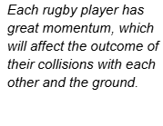



Linear Momentum
The scientific definition of linear momentum is consistent with most people’s understanding of momentum: a large, fast-moving object has greater momentum than a smaller, slower object. Linear momentum is defined as the product of a system’s mass multiplied by its velocity. In symbols: p = mv.

Momentum is directly proportional to the object’s mass and also its velocity. Thus, the greater the mass and the greater the velocity, the greater the momentum.

Momentum p is a vector having the same direction as the velocity. The SI unit for momentum is kg$⋅$m/s

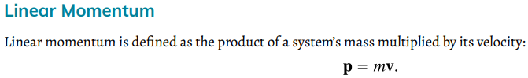
Example 1. Calculating the momentum of a football player and a football.

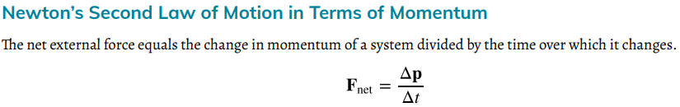
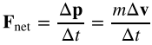

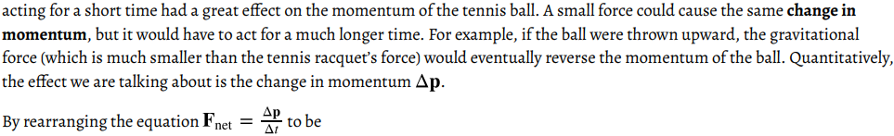

Impulse: the Change in Momentum- Impulse Momentum Theorem:
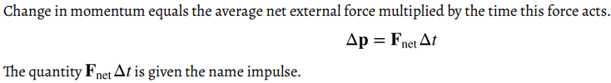
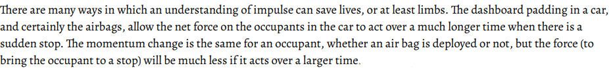

Example 2. Explain why the children’s playground floor is made from soft materials?

Practice Problems
Introduction to Momentum
P = mV (Momentum=mass*Velocity)
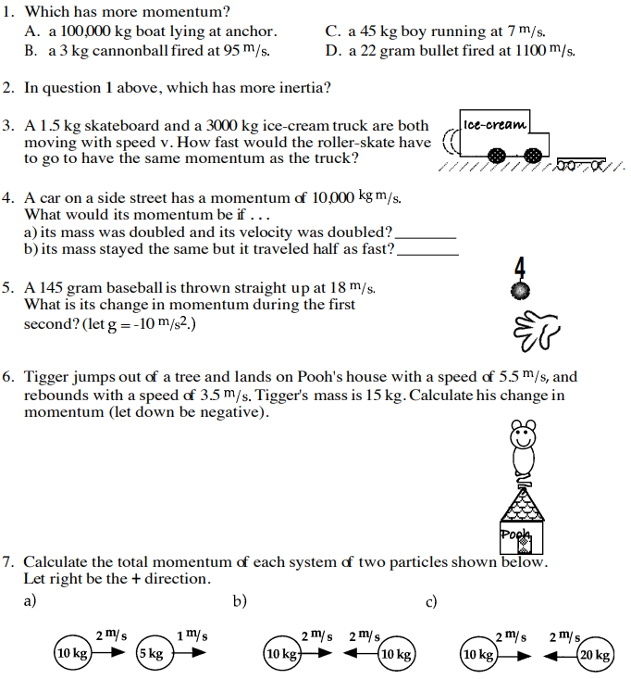

Impulse
J = F*∆t (Impulse = Force* time),

Impulse-Momentum Theorem: F*∆t = ∆p, or F*∆t = $mv_{f}-mv_{i}$
